22.14: a) 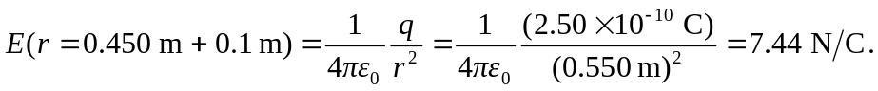
b) 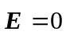 inside of a conductor or else free charges would move under the influence of forces, violating our electrostatic assumptions (i.e., that charges aren’t moving).

